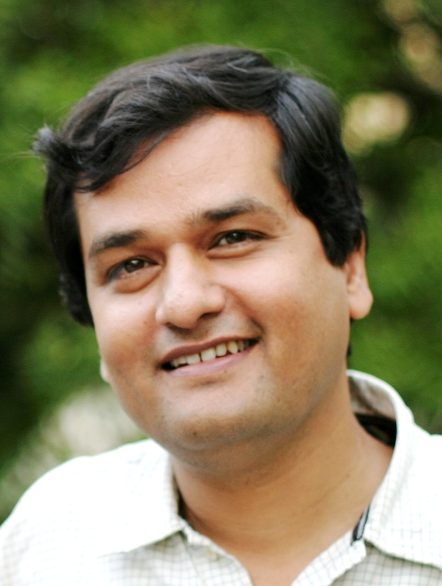
Pallavi Presents…

Baithak style Dhrupad concert
by
Pandit Uday Bhawalkar
With
Manik Munde on Pakhawaj

Sunday: 4/3/05; 4-7PM
At
2002 Philomena Dr
Schenectady (Guilderland) 12303

Donation: $ 20/person; $ 50 / family of four
$10/Student
Seating limited to about 55. Please call early.
Please make checks payable to Pallavi of the Capital District.
Mail to Nalini Madiwale, 2002 Philomena Dr. Schenectady, NY 12303
Phone: 356-2688; e-mail: nalinim01@yahoo.com

Dhrupad: Precursor of Khyal. Dagar Bani has been the predominant voice of Dhrupad since the 1600s. Pandit Bhawalkar is a disciple of Ustads Fariduddin & Zia Mohiuddin Dagar.
Uday Bhawalkar is the powerful background voice in the film Mr. & Mrs. Iyer.

The concert venue is our residence: Take Carman Rd to Spawn Rd.
About 1/2mile up on Spawn, Left on Philomena Dr.
We are at the corner of Spawn & Philomena

